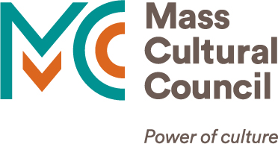

**How to Log In to the** [**Grants Management System**](https://massculturalcouncil.smartsimple.com/s_Login.jsp?lang=1)

This is an overview of how to log in to Mass Cultural Council’s grants management system. You must create an account in our grants management system to submit grant applications, and to receive communications from Mass Cultural Council about your applications, funding, and reports.

If you need help accessing your account after reviewing these instructions, please contact us at [**grants.team**](mailto:grants.team)**@mass.gov.**

**Contents**

1. **Log in to your Account** 2

2. **Register as an Individual** 3

3. **Register as an Organization** 4

4. **Troubleshooting** 5

4.1. **Not Receiving Email Settings** 5

4.2. **Internet Browser** 5

4.3. **Multiple Failed Login Attempts** 5

# **1. Log in to your Account**

[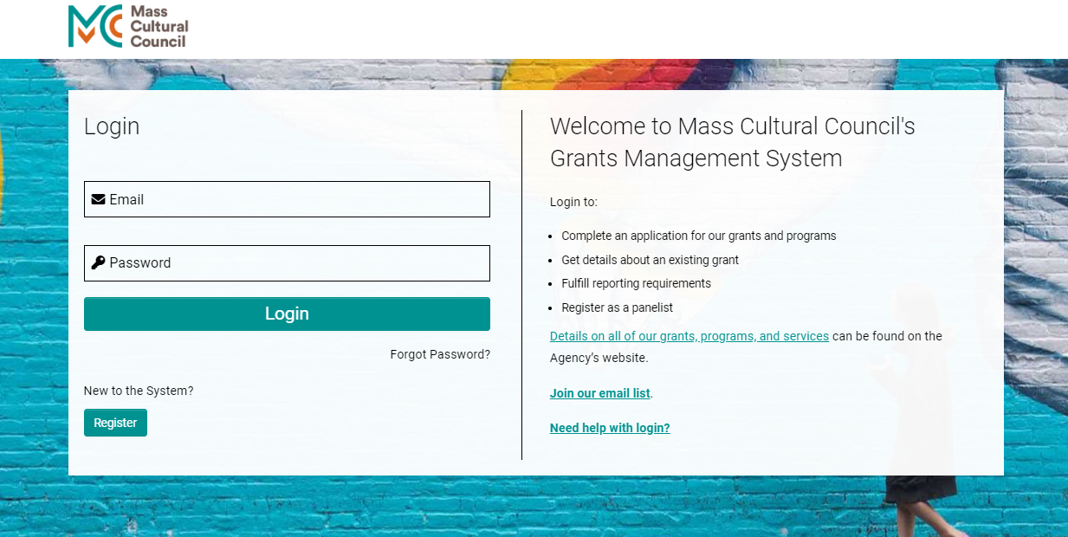](https://massculturalcouncil.smartsimple.com/s_Login.jsp)

[**https://massculturalcouncil.smartsimple.com/s_Login.jsp**](https://massculturalcouncil.smartsimple.com/s_Login.jsp)

**If you have previously applied for a Mass Cultural Council grant using your email address,** you may have a profile in the system already. Here's how you can check:

* Go to the [**grants management system**](https://massculturalcouncil.smartsimple.com/s_Login.jsp) and click "Forgot Password".
* Once you submit your email address, you will receive an email with a link to reset your password that is active for 48 hours.

If you do not receive an email, then you do not have an account and you can create one.

**If you have not applied to Mass Cultural Council before and/or do not already have a user profile,** complete a registration in the grants management system.

You can register and apply as an **Individual** or on behalf of an **Organization**, or both. (Please note that our grants management system requires a unique email address for each type of account.)

# **2. Register as an Individual**

If you want to apply for grants for yourself as an Individual, as part of a collaboration, or for a project you are leading:

* Go to the [**grants management system**](https://massculturalcouncil.smartsimple.com/s_Login.jsp)and click "Register".
* On the next page select "Individual".
* Provide your contact information, answer the optional demographic questions, and accept the Terms & Conditions. Click “Submit”.

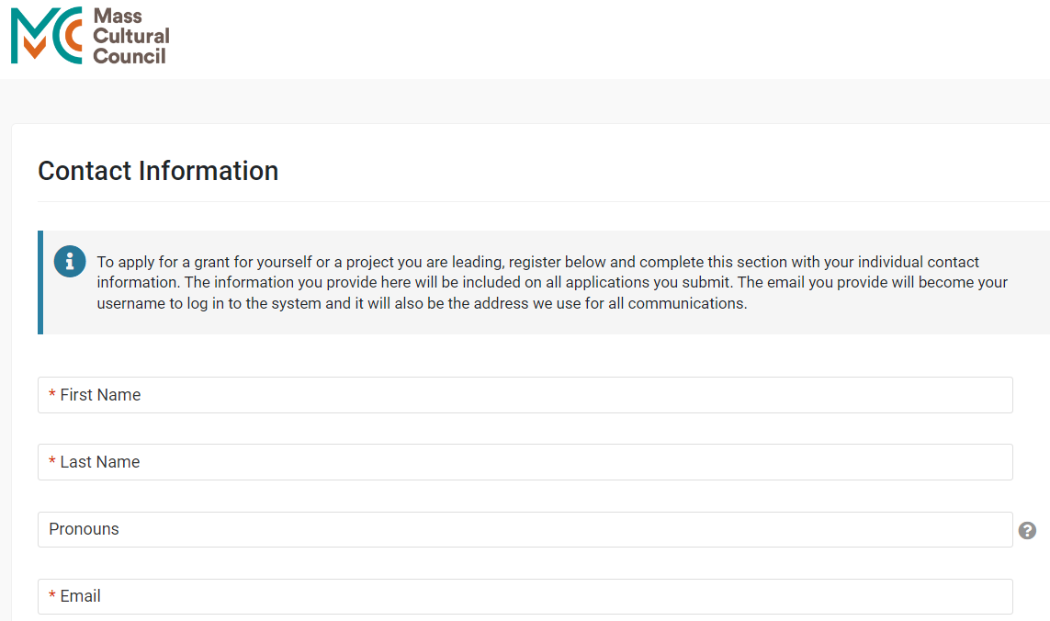

After submitting, you will receive an email from “MassCultural_noreply@smartsimple.com” to activate your account.

You must activate within 48 hours. You will be prompted to create a password after clicking the activation link. You are ready to apply!

# **3. Register as an Organization**

If you want to apply for a grant on behalf of an Organization (including schools, city/towns, unincorporated groups, etc.):

* Go to the [**grants management system**](https://massculturalcouncil.smartsimple.com/s_Login.jsp) and click "Register".
* On the next page select "Organization".
* Your organization may already exist in the system. Use the **Organization Name** field to find and select your organization, then provide your contact information and accept the Terms & Conditions. Click “Submit”.

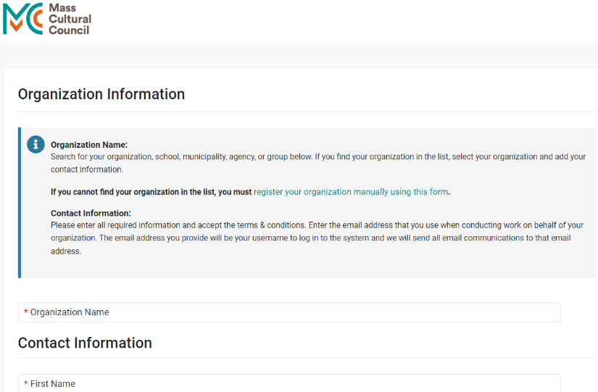

After submitting the registration form, you will receive an email from “MassCultural_noreply@smartsimple.com” to activate your account. You must activate within 48 hours. You will be prompted to create a password after clicking the activation link. You are ready to apply!

**If your organization's name is not in the system**, click the link “register your organization manually using this form” at the top of the page.

* On the next page, answer the brief Pre-registration Eligibility Quiz. Click “Submit”.
* Provide the required information for the organization, your contact information, and accept the Terms & Conditions. Click “Submit”.

After submitting the registration form, you will receive an email from “MassCultural_noreply@smartsimple.com” to activate your account. You must activate within 48 hours. You will be prompted to create a password after clicking the activation link. You are ready to apply!

# **4. Troubleshooting**

## **4.1. Not Receiving Email Settings**

If you have not received any emails from “MassCultural_noreply@smartsimple.com” to date:

* Check your privacy or security settings, or check with IT at your organization, about how to add “MassCultural_noreply@smartsimple.com” as a trusted contact in your email account.
* Some users who have an email alias or who use an email provider such as AOL/Verizon to log into their accounts with Mass Cultural Council have reported that they do not receive system emails. We recommend using a Gmail or Outlook email account as your username whenever possible.

## **4.2. Internet Browser**

For the best experience when using our grants system, we suggest that you use the latest versions of Chrome or Safari.

## **4.3. Multiple Failed Login Attempts**

If you experience **multiple failed login attempts**, you may have a **reCAPTCHA** box included as part of the log in process. Click the “I’m not a robot” box when prompted to indicate that you are not a robot.

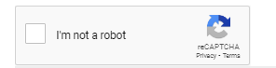

**If you need further support, please email the Grants Team at** [**grants.team@mass.gov**](mailto:grants.team@mass.gov)**.**